**Sheet 6**



Abishek Kumar

Ravikant Tyagi

Erce Can Balcioglu

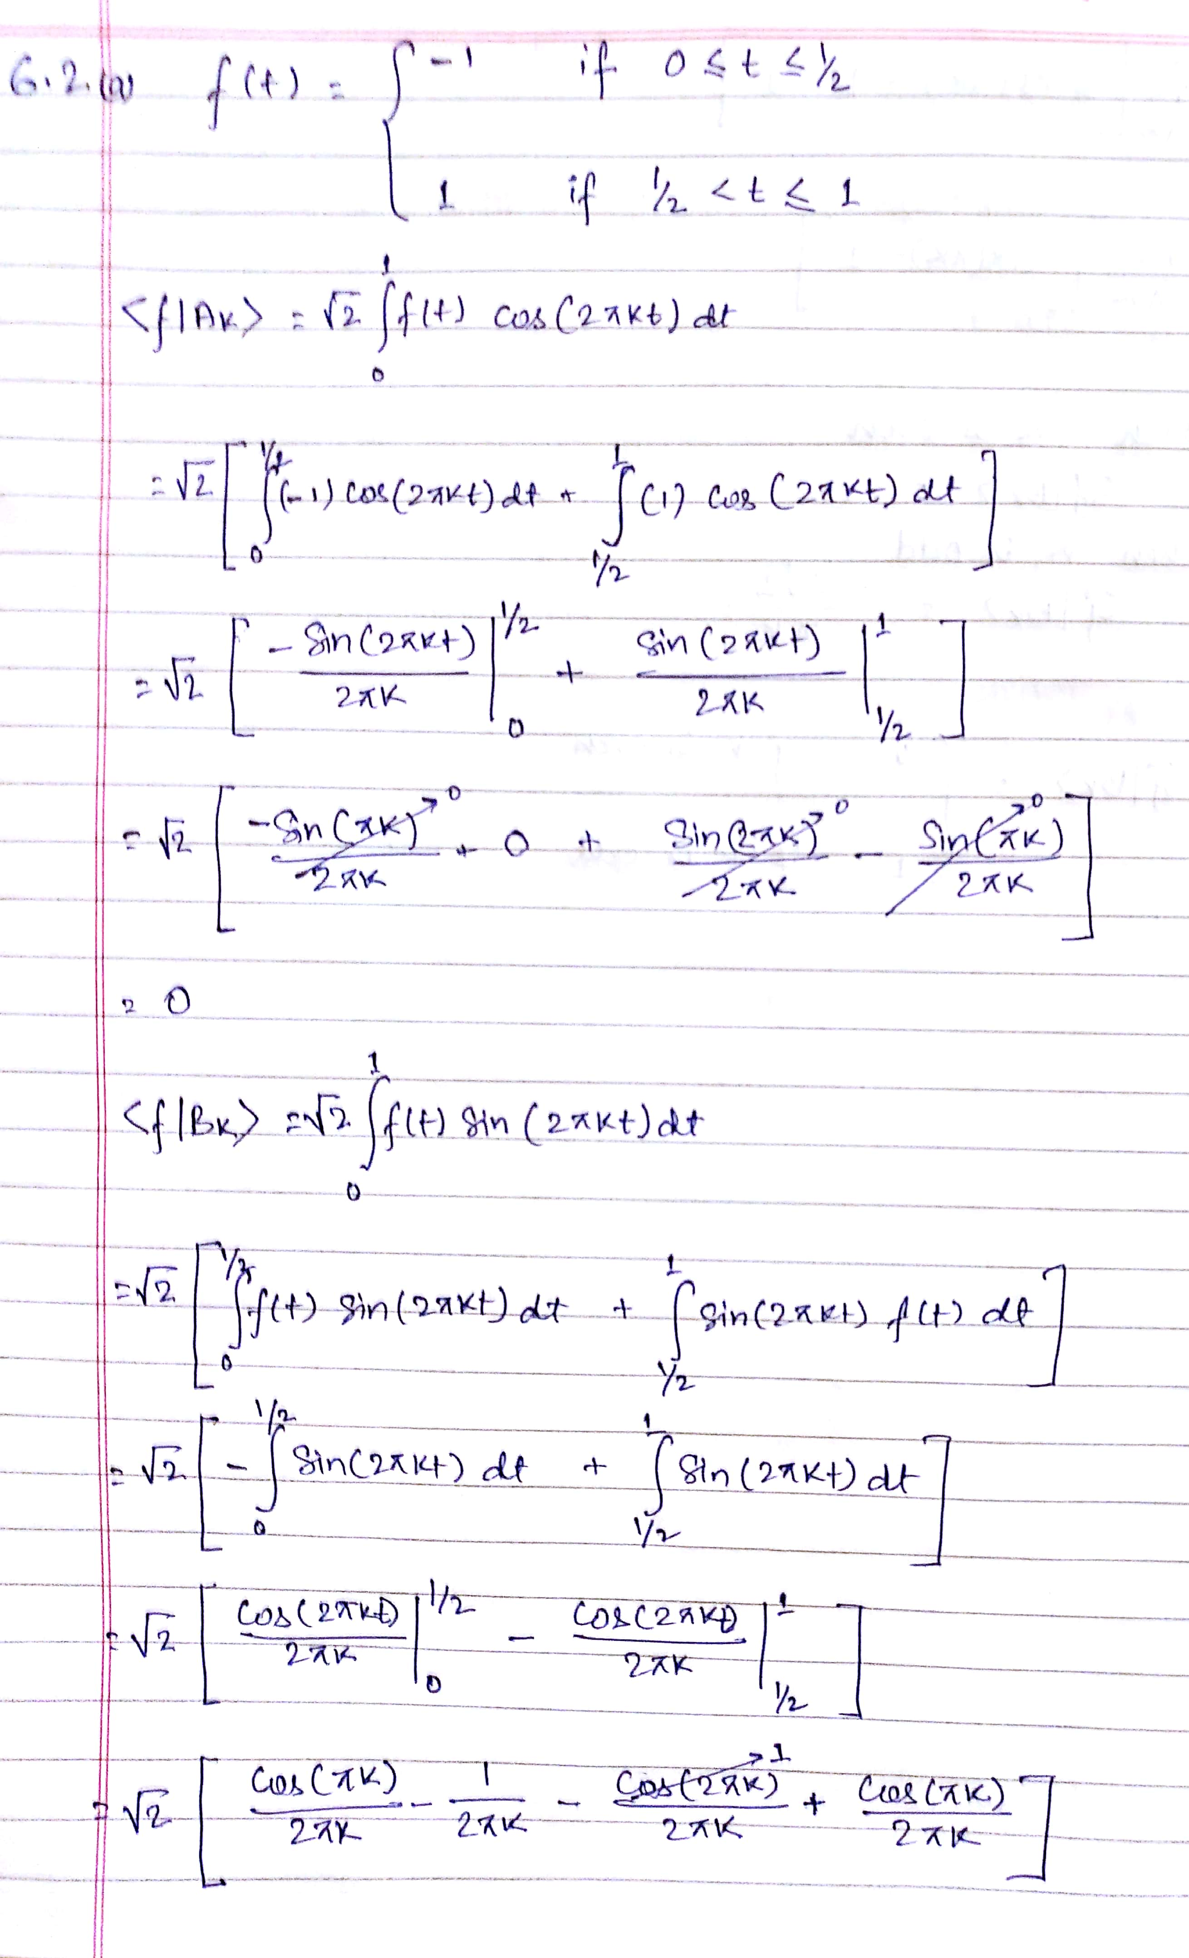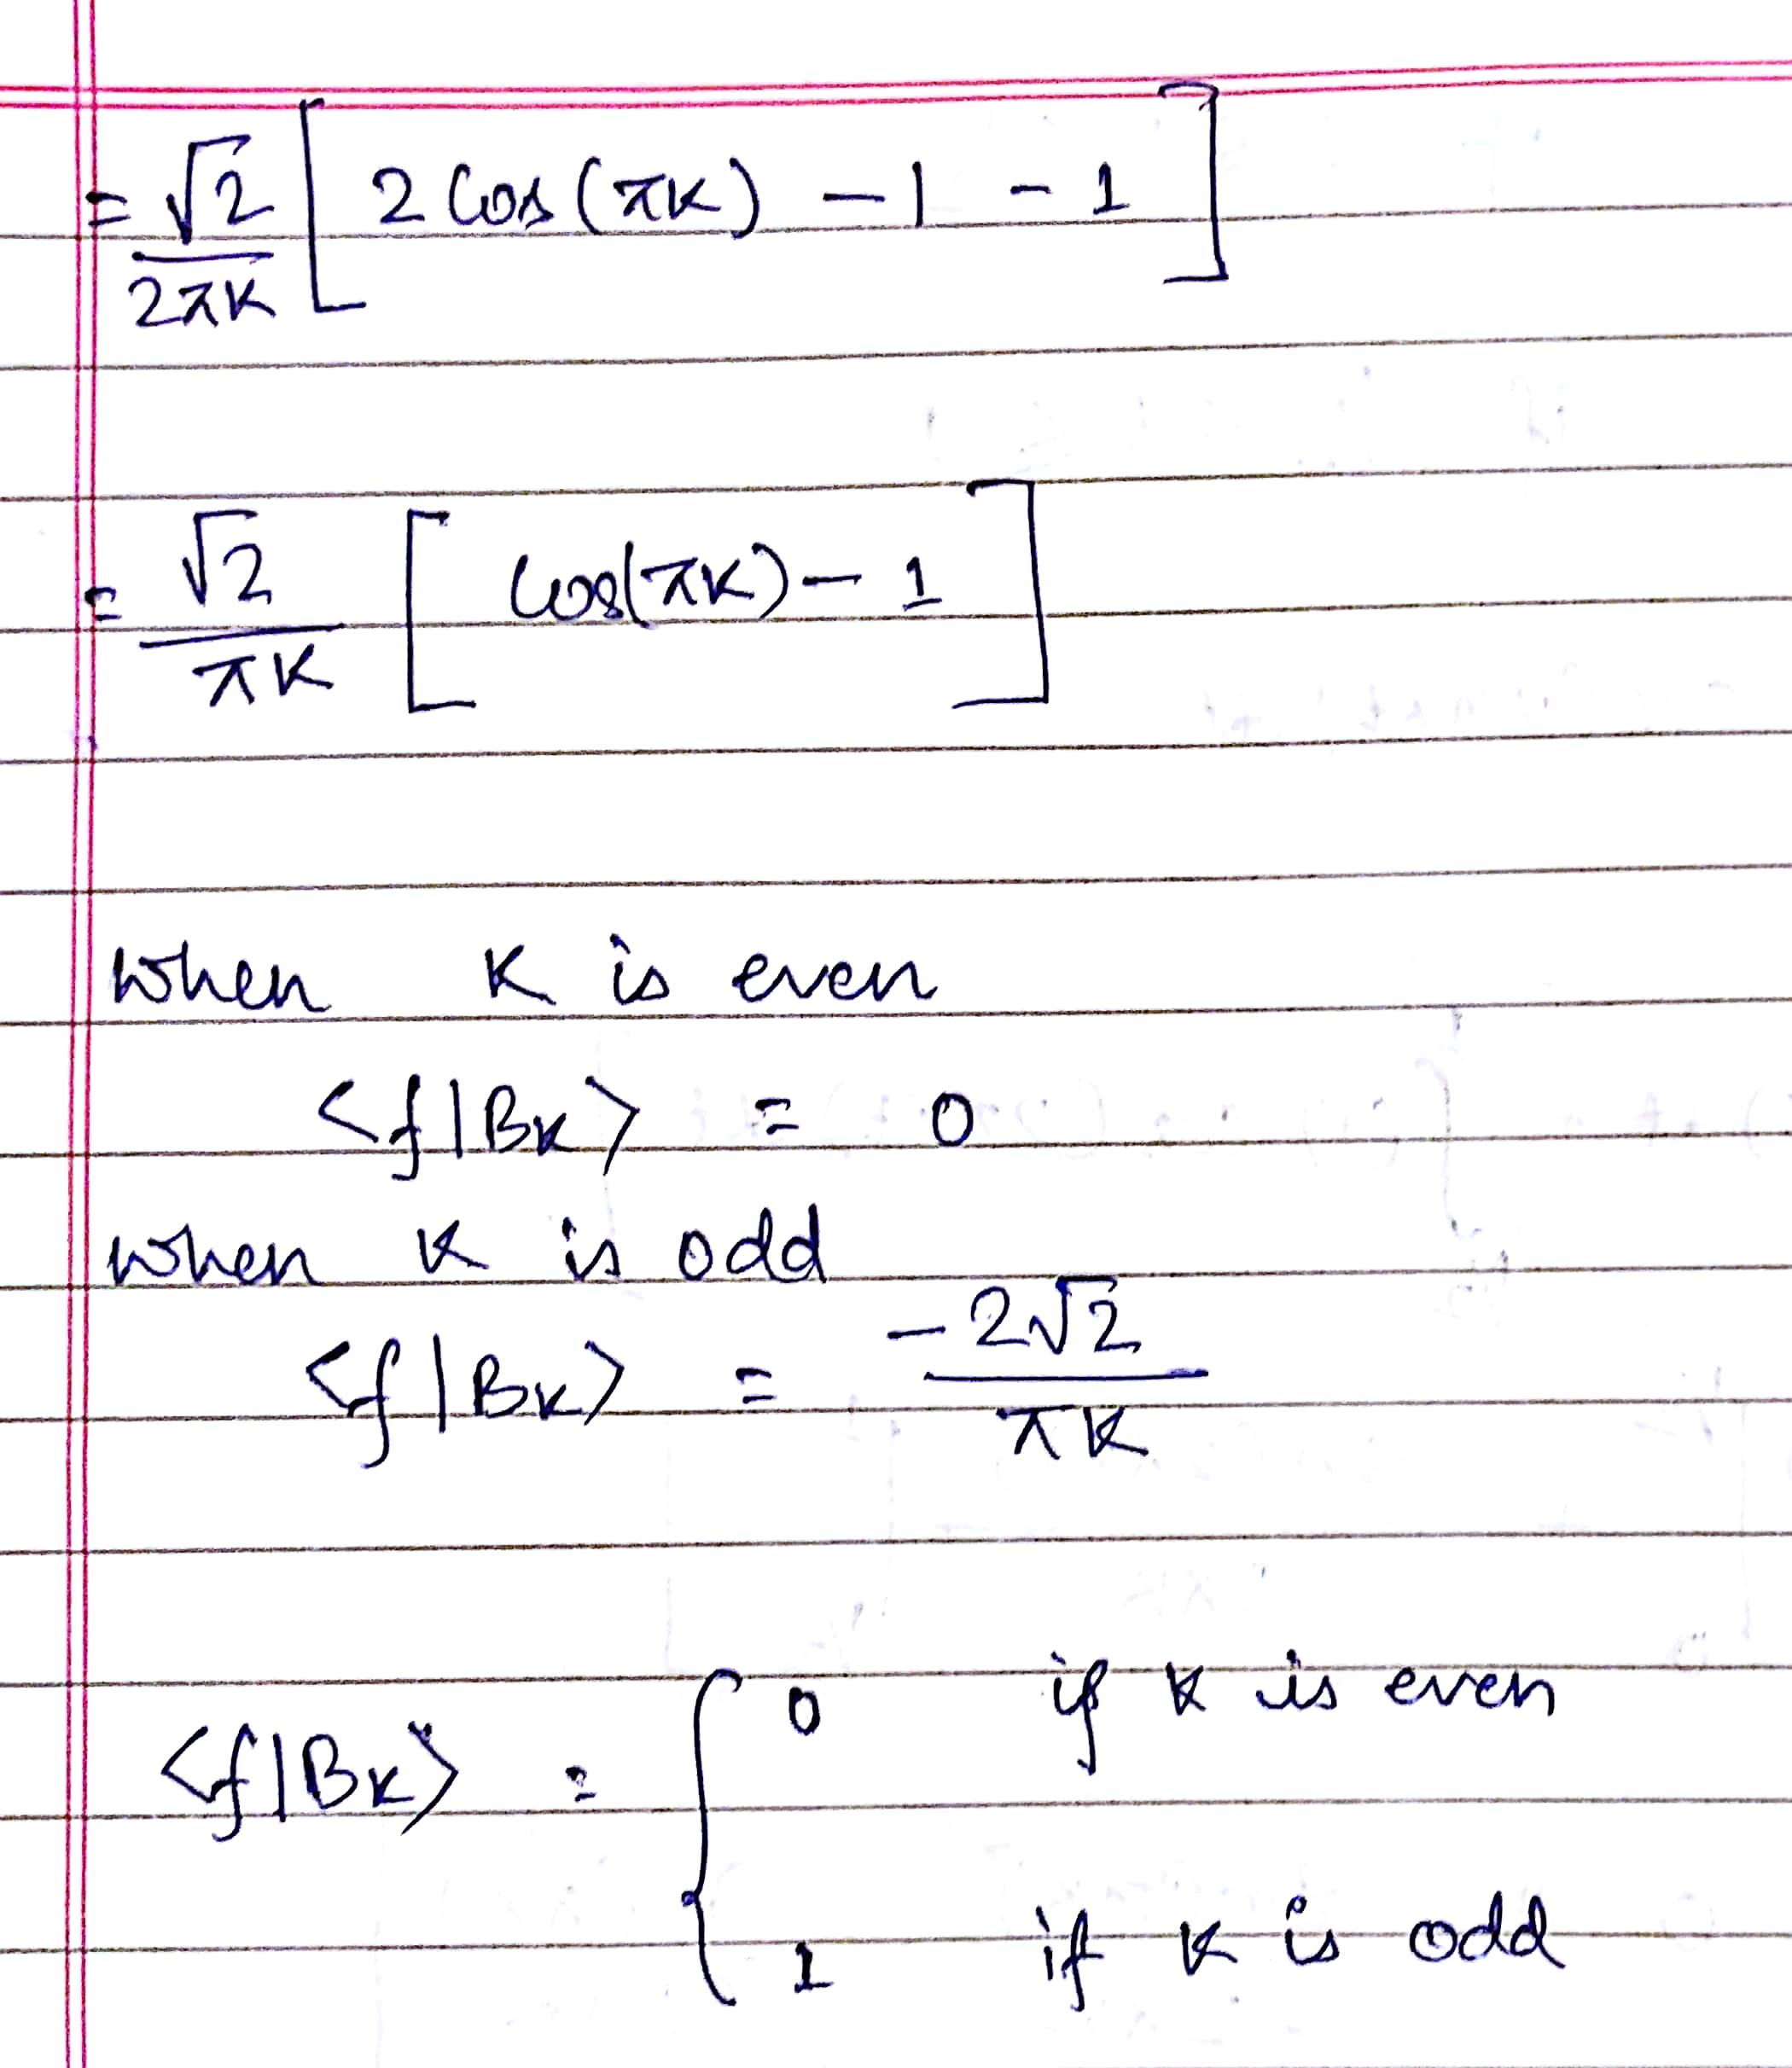



6.2 c

Sample output for k=25 (for each increasing k there will be a new signal added to the signal space with increasing frequency and decreasing amplitude.)



